**Glossary:**

**Resource tokens:** These help you keep track of your team’s budget. You have a budget for for **Developer Time** and one for **User Trust**. Make sure that you don’t run out of either resource!

* **Developer Time:** represented by 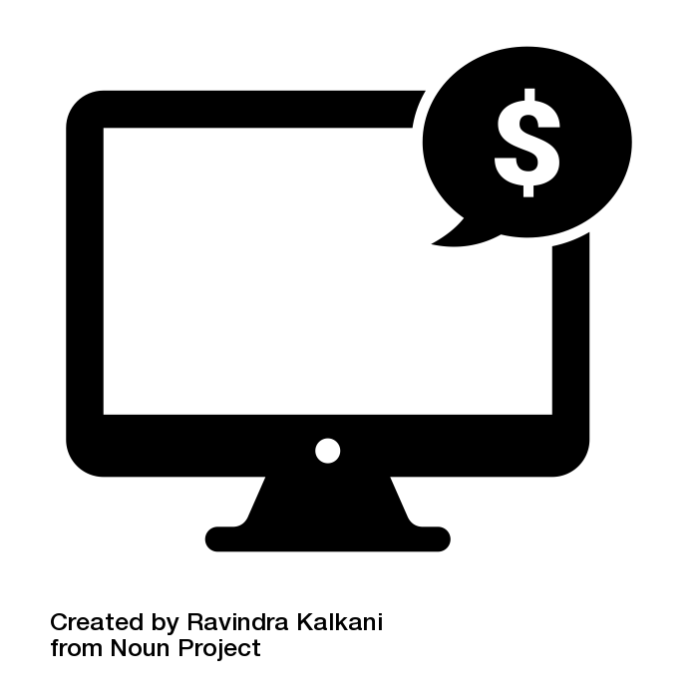 on the board, developer time reflects how much of the company’s resources are being spent on your app. Collecting developer time is important because it helps you build more, bigger, and better products.
* **User Trust:** represented by  on the board, user trust reflects how users perceive your app. Collecting user trust is important because it helps ensure that customers want to use your app.

**Roles:** Your role is your position on the mobile app development team. Roles include the **Developer**, the **User Experience (UX) Designer**, and the **Manager**. While you win or lose as a team, you don’t always have the same motivations.

* **Developer.** The developer cares about the product working well. The developer prioritizes the resource of “developer time,” because their time is a precious resource for making the product work well. Try not to let developer time fall below 10.
* **User Experience (UX) Designer.** The UX designer cares about the user experience using the app. The UX designer prioritizes the game resource of “user trust”, because this is how user satisfaction is measured. Try not to let user trust fall below 10.
* **Manager.** The manager strives for a balanced product. They must monitor both the resource of “developer time,” because this is how they will build a bigger team, and also the resource of “user trust,” because this is how they will ensure that their product has a customer base. Try not to let either developer time or user trust fall below 10.

**What information is being collected?:** The goal of this game is to create a privacy policy, in which you lay out how your company will use and share six types of information available to your application. The types of information are **Demographic Information**, **Health Information**, **Purchasing Information**, **Contact Lists**, **Site Activity**, and **Location Data**.

* **Demographic Information:** Demographic information is data about a person that doesn't necessarily identify them. It may include things like gender, race, age, health status, income, education level, or employment status.
* **Health Information:** Health information is data about a person’s health. This may include things like glucose levels, weight, BMI, medications, cholesterol levels, or blood pressure. (All of these are collected in various real-life diabetes-related apps:

<https://www.healthline.com/health/diabetes/top-iphone-android-apps#diabetes:m>)

* **Purchasing Information:** Purchasing information is data collected in the process of making purchases. This may include sensitive information such as credit card numbers or bank account numbers.
* **Contact Lists:** Contact lists are lists of people connected with your users - for instance, their phone book contacts or their friends on social media.
* **Site Activity:** Site Activity is data collected about how users use your app - for instance, how long they use certain functions or how often they check the app.
* **Location Data:** Location data is GPS data about where users are when they use your app (or, if you choose, even when they’re not using your app).

**Why is information being collected?:** Your team’s privacy policy will focus on three potential uses for collecting data: to **Maintain Service**, to support **Marketing** ofthe app, and to support **User Profiles** on the app.

* **Maintain Service:** This is the basic functionality of your app. Consider what user information your app needs to make its basic functions run.
* **Marketing:** This is how you will increase the public’s awareness of your app, whether through advertisements, word-of-mouth, or partnerships with other companies. Consider what user information would be useful to effectively market your app, both to the general public and to specific market segments.
* **User Profiles:** This is how you determine what categories or types of people currently use your app, and use those to better predict their behavior and tailor their experience with the app (as well as predict future products they might want). Consider what user information you will need to develop profiles of the types of people who use your app.

**Who is information being shared with?:** Your team’s privacy policy will focus on three groups you might sell data to, or share data with: **Other Companies**, **Academic Researchers**, and **the Government**.

* **Other Companies** may want to pay you for access to the data you decide to collect.
* **Academic Researchers** may want access to your data to further their research (for example, to study the impact of your app on the health of your users).
* Federal, state, and local **Governments** may request - or demand - access to your data, for instance to solve crimes.

**Event Cards**: The game board will instruct you to draw a certain number of cards at certain times. Event cards represent the many things in design you can't see coming. You'll be presented with new opportunities and challenges that you'll have to make decisions about, and you may gain or lose resources depending on the decisions you've already made.